Table 1. Emission inventory and pre-processing requirements data used in this study

|  |  |  |  |  |
| --- | --- | --- | --- | --- |
| Sector | Emission Inventory | Chemical speciation profile | Spatial surrogate | Temporal profile |
| Point and Area Oil and Gas | CDPHE 2014 emission | CMAQ CB06 profiles from EPAv6.3 platform | EPA U.S. spatial surrogate (CONUS12km and CONUS4km) | Sector profiles from EPA2011v6.3 platform |
| Onroad mobile | 12km: 2017 onroad mobile activity data EPA2011v6.3 platform  4km: Alpine geophysics 2017 mobile activity data emission | CMAQ CB06 profiles from EPAv6.3 platform | 12km: EPA U.S. spatial surrogate  4km: Alpine geophysics surrogation | Based on activity data and meteorological simulation data |
| Other point, area and mobile | 2017 sector emissions from EPA2011v6.3 platform | CMAQ CB06 profiles from EPAv6.3 platform | EPA U.S. spatial surrogate | Sector profiles from EPA2011v6.3 platform |
| Biogenic | Based on BEIS v3.61 | CMAQ CB06 profiles from EPAv6.3 platform | Spatial allocation using BELD4 | In-line calculation using spatial surrogate and meteorological data |
| Fire | FINN v1.5 |  |  | Daily constant value |

\* CDPHE : Colorado Department of Public Health and Environment, US EPA: United States Environmental Protect Agency, BEIS: Biogenic Emission Inventory System, BELD: Biogenic Emissions Land use Database v4, FINN: Fire INventory in NCAR

Table 2. Observations used for model evaluation at 7 sites used in the analysis

|  |  |  |  |
| --- | --- | --- | --- |
| Site | Surface | Area/Vertical | Vertical Profile |
| Fort Collins West |  | C130 (NO, NO2, CO, ethane, benzene, toluene) | P3B (NO, NO2, CO, ethane, benzene, and toluene) |
| Platteville | NATIVE: wind speed, wind direction, temperature, relative humidity, ozone, NO, NO2, and CO  WAS: ethane  PTR-QMS: benzene, toluene  MPL: PBL height | C130 (NO, NO2, CO, ethane, benzene, toluene) | P3B (NO, NO2, CO, ethane, benzene, and toluene)  NATIVE O3 sonde (wind speed, wind direction, temperature, relative humidity, and ozone) |
| Golden |  | C130 (NO, NO2, CO, ethane, benzene, toluene) | P3B (NO, NO2, CO, ethane, benzene, and toluene) |
| BAO Tower |  | C130 (NO, NO2, CO, ethane, benzene, toluene) | P3B (NO, NO2, CO, ethane, benzene, and toluene) |
| Denver LaCasa |  | C130 (NO, NO2, CO, ethane, benzene, toluene) | P3B (NO, NO2, CO, ethane, benzene, and toluene) |
| Chatfield Park |  | C130 (NO, NO2, CO, ethane, benzene, toluene) | P3B (NO, NO2, CO, ethane, benzene, and toluene) |
| Greeley |  | C130 (NO, NO2, CO, ethane, benzene, toluene) | P3B (NO, NO2, CO, ethane, benzene, and toluene) |

Table 3. Model performances of 5 species against surface and P3B aircraft measurements between 10 and 17 local times over the six sites. Surface observations were sampled to match P3B measurement times per observation site, and P3B observations were divided by below 1 km, and 1 – 3 km above ground. All statistical metrics are unitless except MB with unit of ppbv.

|  |  |  |  |  |  |  |  |  |  |  |  |  |  |  |  |  |  |  |  |
| --- | --- | --- | --- | --- | --- | --- | --- | --- | --- | --- | --- | --- | --- | --- | --- | --- | --- | --- | --- |
|  | | Fort Collins West | | | Platteville | | | Golden | | | BAO | | | Denver | | | Chatfield Park | | |
| MB | MNB | R | MB | MNB | R | MB | MNB | R | MB | MNB | R | MB | MNB | R | MB | MNB | R |
| NOX | Surface | 0.25 | 0.12 | 0.41 | 11.95 | 1.27 | 0.58 |  |  |  |  |  |  |  |  |  |  |  |  |
| < 1km | -0.37 | -0.25 | 0.52 | -0.26 | -0.15 | 0.26 | -0.45 | -0.16 | 0.24 | -0.38 | -0.22 | 0.62 | -3.24 | -0.44 | 0.66 | 0.34 | 0.16 | -0.03 |
| 1 to 3km | 0.04 | 0.35 | 0.55 | 0.00 | 0.01 | 0.32 | 0.05 | 0.22 | 0.52 | -0.08 | -0.36 | 0.49 | -0.14 | -0.15 | 0.62 | -0.03 | -0.09 | 0.63 |
| CO | Surface |  |  |  | -13.70 | -0.09 | 0.38 |  |  |  |  |  |  |  |  |  |  |  |  |
| < 1km | -13.41 | -0.11 | 0.24 | -15.36 | -0.13 | 0.18 | 1.18 | 0.01 | 0.13 | -14.72 | -0.12 | 0.37 | 1.24 | 0.01 | 0.45 | 8.26 | 0.06 | 0.15 |
| 1 to 3km | -2.47 | -0.03 | 0.51 | -5.13 | -0.06 | 0.52 | 1.24 | 0.01 | 0.50 | -5.36 | -0.06 | 0.72 | 4.00 | 0.04 | 0.52 | -0.53 | -0.01 | 0.67 |
| Ethane | Surface |  |  |  |  |  |  |  |  |  |  |  |  |  |  |  |  |  |  |
| < 1km | -1.70 | -0.41 | 0.26 | 4.23 | 0.32 | 0.25 | 0.48 | 0.14 | 0.53 | 5.64 | 0.65 | 0.59 | 1.62 | 0.30 | 0.51 | 0.73 | 0.25 | 0.41 |
| 1 to 3km | 0.06 | 0.06 | 0.36 | 0.61 | 0.34 | 0.34 | 0.53 | 0.49 | 0.69 | 1.12 | 0.78 | 0.65 | 0.25 | 0.18 | 0.63 | 0.63 | 0.49 | 0.71 |
| Benzene | Surface |  |  |  | -13.70 | -0.09 | 0.38 |  |  |  |  |  |  |  |  |  |  |  |  |
| < 1km | -0.05 | -0.61 | 0.28 | -0.10 | -0.67 | 0.26 | -0.03 | -0.30 | 0.23 | -0.06 | -0.62 | 0.63 | -0.04 | -0.30 | 0.47 | -0.02 | -0.27 | 0.04 |
| 1 to 3km | -0.02 | -0.68 | 0.23 | -0.02 | -0.68 | 0.39 | -0.02 | -0.52 | 0.40 | -0.02 | -0.69 | 0.58 | -0.01 | -0.38 | 0.48 | -0.02 | -0.54 | 0.53 |
| Toluene | Surface |  |  |  | -13.70 | -0.09 | 0.38 |  |  |  |  |  |  |  |  |  |  |  |  |
| < 1km | 0.00 | 0.02 | 0.36 | -0.07 | -0.54 | 0.27 | 0.05 | 0.51 | 0.15 | -0.03 | -0.31 | 0.62 | 0.01 | 0.03 | 0.47 | 0.06 | 0.63 | -0.02 |
| 1 to 3km | 0.01 | 2.43 | 0.25 | 0.00 | 0.34 | 0.25 | 0.02 | 1.48 | 0.47 | 0.00 | 0.12 | 0.51 | 0.03 | 0.89 | 0.63 | 0.01 | 0.90 | 0.58 |

\* MB: Mean bias, NMB: normalized mean bias, R: spatial correlations

Table 3. Model performances of 5 species against C130 measurements between 10 and 17 local times over Front Range (Fig. 1) and areas within 0.1 degree from each site. Statistical metrics used in this table is the same in Table 1.

|  |  |  |  |  |  |  |  |  |  |  |  |  |  |  |  |  |  |  |  |  |  |  |
| --- | --- | --- | --- | --- | --- | --- | --- | --- | --- | --- | --- | --- | --- | --- | --- | --- | --- | --- | --- | --- | --- | --- |
|  | | Total | | | Fort Collins West | | | Platteville | | | Golden | | | BAO | | | Denver LaCasa | | | Chatfield Park | | |
| MB | MNB | R | MB | MNB | R | MB | MNB | R | MB | MNB | R | MB | MNB | R | MB | MNB | R | MB | MNB | R |
| NOX | < 1km | -0.90 | -0.38 | 0.46 | -0.31 | -0.30 | 0.75 | -0.19 | -0.13 | 0.56 | -2.38 | -0.49 | 0.74 | -1.02 | -0.39 | 0.62 | -7.21 | -0.58 | 0.21 | 0.45 | 0.23 | 0.39 |
| 1 to 3km | -0.13 | -0.25 | 0.40 |  |  |  | -0.63 | -0.58 | 0.98 |  |  |  | -0.12 | -0.19 | 0.63 | -1.32 | -0.40 | 0.19 | 0.66 | 1.15 | -0.07 |
| CO | < 1km | -55.59 | -0.32 | 0.10 | 15.82 | 0.16 | 0.49 | 16.77 | 0.17 | 0.39 | -12.64 | -0.09 | 0.53 | -3.57 | -0.03 | 0.30 | -1.22 | -0.01 | 0.36 | 25.73 | 0.21 | 0.37 |
| 1 to 3km | -14.69 | -0.13 | 0.11 |  |  |  |  |  |  |  |  |  | -4.39 | -0.04 | 0.37 | 19.53 | 0.16 | 0.71 | 16.96 | 0.15 | 0.25 |
| Ethane | < 1km | 1.56 | 0.23 | 0.43 | -0.23 | -0.06 | -0.48 | 2.25 | 0.19 | -0.11 | -0.66 | -0.16 | 0.68 | 8.49 | 0.63 | 0.58 | 2.93 | 0.59 | 0.81 | 1.29 | 0.41 | 0.97 |
| 1 to 3km | 1.32 | 0.60 | 0.45 |  |  |  |  |  |  |  |  |  | 1.44 | 0.50 | 0.54 | 0.32 | 0.22 | -0.28 |  |  |  |
| Benzene | < 1km | -0.05 | -0.58 | 0.35 | -0.03 | -0.49 | -0.58 | -0.10 | -0.76 | 0.02 | -0.04 | -0.48 | 0.48 | -0.09 | -0.66 | 0.51 | -0.03 | -0.23 | 0.31 | -0.05 | -0.41 | 0.64 |
| 1 to 3km | -0.02 | -0.54 | 0.38 |  |  |  |  |  |  |  |  |  | -0.03 | -0.60 | 0.08 | -0.01 | -0.11 | 0.00 |  |  |  |
| Toluene | < 1km | -0.04 | -0.34 | 0.61 | 0.01 | 0.08 | -0.48 | -0.08 | -0.71 | 0.57 | -0.04 | -0.24 | 0.51 | -0.08 | -0.52 | 0.73 | -0.06 | -0.18 | 0.49 | -0.02 | -0.09 | 0.79 |
| 1 to 3km | 0.00 | -0.01 | 0.22 |  |  |  |  |  |  |  |  |  | -0.01 | -0.21 | 0.46 | 0.00 | -0.03 | 0.03 |  |  |  |

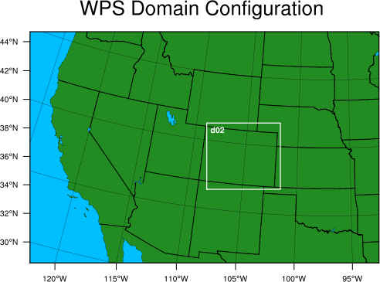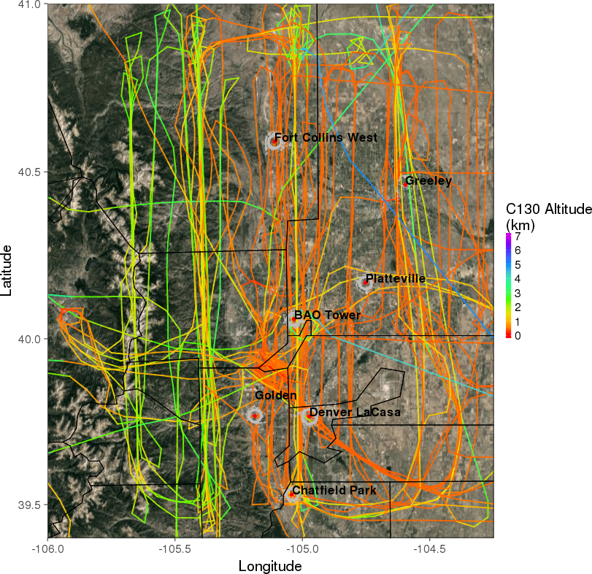

Figure 1. (Left) Model domains for western U.S (12 km x 12 km) and around Colorado (4km x 4km) used in this study and (right) 7 ground sites represented by red dots focused at the analysis , C130 flight paths with colored lines showing altitude above ground and P3B spiraling location represented by grey dots over Front range area during FRAPPÉ-DISCOVER AQ campaign.

|  |  |  |
| --- | --- | --- |
|  |  |  |
|  |  |  |

Figure 2. 2014 total emissions (including anthropogecin, biogenic and fire emissions) (top) and the contribution of oil and gas prodiction emission to the total emissions (bottom) for CO (left), NOx (middle) and VOC (right) per county over Colorado based on EPA National Emissions Inventory (NEI) Data (<https://www.epa.gov/air-emissions-inventories/2014-national-emissions-inventory-nei-data>). The distribution of active oil and gas wells in 2014 is also shown in the contribution figures. Emissions from portable facilities are excluded. Each emission rate and contribution are log-scaled.

|  |  |  |
| --- | --- | --- |
| D:\TASK_DATA\FRAPPE\PIC\NEW_ANALYSIS\NOX_OBS_C130_0_1km.png | D:\TASK_DATA\FRAPPE\PIC\NEW_ANALYSIS\NOX_MODEL_C130_0_1km.png | D:\TASK_DATA\FRAPPE\PIC\NEW_ANALYSIS\NOX_DIFF_C130_0_1km.png |

Figure 3. NOX concentrations of (left) C130 measurements, (center) model simulation, and (right) differences between model and observation of NOX concentrations below 1km over the Front Range. All data are averaged by 0.1° x 0.1° spatial resolution.

|  |  |  |
| --- | --- | --- |
| D:\TASK_DATA\FRAPPE\PIC\NEW_ANALYSIS\CO_OBS_C130_0_1km.png | D:\TASK_DATA\FRAPPE\PIC\NEW_ANALYSIS\CO_MODEL_C130_0_1km.png | D:\TASK_DATA\FRAPPE\PIC\NEW_ANALYSIS\CO_DIFF_C130_0_1km.png |

Figure 4. Same as Fig. 3. except for CO concentrations

|  |  |  |
| --- | --- | --- |
| D:\TASK_DATA\FRAPPE\PIC\NEW_ANALYSIS\ETHA_OBS_C130_0_1km.png | D:\TASK_DATA\FRAPPE\PIC\NEW_ANALYSIS\ETHA_MODEL_C130_0_1km.png | D:\TASK_DATA\FRAPPE\PIC\NEW_ANALYSIS\ETHA_DIFF_C130_0_1km.png |

Figure 5. Same as Fig. 3, except for ethane concentrations

|  |  |  |
| --- | --- | --- |
| D:\TASK_DATA\FRAPPE\PIC\NEW_ANALYSIS\BENZ_OBS_C130_0_1km.png | D:\TASK_DATA\FRAPPE\PIC\NEW_ANALYSIS\BENZ_MODEL_C130_0_1km.png | D:\TASK_DATA\FRAPPE\PIC\NEW_ANALYSIS\BENZ_DIFF_C130_0_1km.png |

Figure 6. Same as Fig. 3, except for benzene concentrations

|  |  |  |
| --- | --- | --- |
| D:\TASK_DATA\FRAPPE\PIC\NEW_ANALYSIS\TOL_OBS_C130_0_1km.png | D:\TASK_DATA\FRAPPE\PIC\NEW_ANALYSIS\TOL_MODEL_C130_0_1km.png | D:\TASK_DATA\FRAPPE\PIC\NEW_ANALYSIS\TOL_DIFF_C130_0_1km.png |

Figure 7. Same as Fig. 3, except for toluene concentrations