Draft 11/01/10

Satellite and ground-based remote sensing of carbon monoxide over Australasia: Linking global and local scales

D. P. Edwards and L. K. Emmons
Program for Atmospheric Composition Remote Sensing & Prediction (ACRESP), National Center for Atmospheric Research, P.O. Box 3000, Boulder CO 80307, USA

N. B. Jones, C. Paton-Walsh, N. M. Deutscher∗, R. R. Buchholz and D. W. T. Griffith
University of Wollongong, Wollongong NSW, Australia

∗Now at Institute of Environmental Physics, University of Bremen, Bremen, Germany

Abstract
Air chemistry observations and monitoring play an important part in understanding the sources and long-range transport of air pollution. No single measurement technique can meet all the scientific requirements because of the different spatial and temporal scales involved. Localized ground-based remote sensing techniques provide insight into chemical processes and fine scale atmospheric chemistry and dynamics, while satellite observations supply the regional context for the localized observations and extend these measurements to continental and global scales.
We present an analysis of the variability of carbon monoxide observations from Australasian ground-based spectrometer stations at Darwin and Wollongong, Australia, and Lauder, New Zealand, with retrievals from the Terra/MOPITT satellite instrument. The spectrometer data capture small-scale urban pollution and bushfire events, and also reflect the hemispheric impact of biomass burning in South America, southern Africa and Indonesia through long-range transport of pollution. The carbon monoxide seasonal and inter-annual variability is found to be significantly different at the three stations and we compare and contrast the spectrometer and satellite perspectives with the aid of a chemical-transport model to distinguish the relative impact of local and remote pollution sources.

Introduction
Air chemistry observations and monitoring play an important part in understanding the sources and transport of air pollution. No single measurement technique can meet all the scientific requirements because of the different spatial and temporal scales involved. Ground-based remote sensing techniques provide insight into chemical processes and fine scale atmospheric chemistry and dynamics. Measurements capture local conditions in great detail, but lack larger scale context to separate local and global influences. They may not be representative of, even slightly, larger regions and with a limited number of stations, coverage is often sparse. These datasets are particularly useful for discerning long-term trends when the measurements can be sustained on a decadal time scale. On the other hand, satellite observations can provide a global, long-term view of atmospheric composition. They supply the regional context for localized observations and help extend these measurements to continental and global scales. However, there are limitations. Orbital constraints and persistent cloud cover can result in poor spatial and temporal sampling and spatial resolution is also fairly coarse. Exploiting the particular strengths of each measurement type through an optimal cross-scale combination using chemical transport modeling as an intermediary will be a goal of future integrated observing strategies such as the Global Earth Observation System of Systems (GEOSS) http://www.epa.gov/geoss/. This will pay dividends for basic science research and applications such as air quality (AQ) characterization and “chemical weather” forecasting
The aim of this paper is to use a combination of ground-based Fourier transform spectrometer (FTS) and satellite gas column measurements to provide the global context to locally observed pollution and investigate the regional and global impact of large local pollution sources. We present an analysis of the variability of carbon monoxide (CO) observations from Australasian FTS stations at Darwin, NT, and Wollongong, NSW, in Australia, and Lauder, New Zealand, with retrievals from the Terra/MOPITT satellite instrument. The spectrometer data capture small-scale urban pollution and bushfire events, and also reflect the hemispheric impact of biomass burning in South America, southern Africa and Indonesia through long-range transport of pollution. The CO seasonal and inter-annual variability is found to be significantly different at the three stations, and we compare and contrast the spectrometer and satellite perspectives with the aid of the Model for OZone and Related chemical Tracers (MOZART-4) to distinguish the relative contributions of local and remote pollution sources. At the same time, the wider geographical impact of Australian fires, such as those that burned around Canberra in 2003, can be traced from the spectrometer to the satellite observations as the CO plumes are exported out across the Pacific Ocean.
In section 2, XXX………

Southern hemisphere carbon monoxide
Tropospheric CO is an ideal species for studying pollution seasonal and interannual variability and transport. CO sources fall into two main classes: chemical production from oxidation of hydrocarbons and direct combustion including anthropogenic urban/industrial fossil fuel and biofuel burning, wildfires, and tropical biomass burning. The principal CO sink is oxidation by the hydroxyl radical (OH), and in the presence of nitrogen oxides (NOx), this contributes to the formation of tropospheric ozone (O3). The mean lifetime of about two months allows substantial time for observations but is not long enough for CO to become evenly mixed in the troposphere. For this reason, CO serves as an excellent tracer of pollution transport and intense pollution sources can produce concentration enhancements over background values of several hundred percent [Edwards et al., 2004; 2006a]. This also results in the planetary boundary layer (PBL) and free troposphere (FT) partial columns of CO often being of comparable magnitude. As a primary indicator of incomplete combustion it can be used as a proxy for inferring emissions and distributions of other species that are not so readily measured.
The SH distribution and seasonal variability of CO is dominated by biomass burning in all its forms [Edwards et al; 2004a; 2004b; XXX]. In general, the hemispheric CO loading reaches a maximum in the austral spring as a result of annual savannah burning in southern Africa (usual peak in August or September) and tropical rainforest and grassland burning in South America (usual peak in September or October). In some years, rainforest fires in the Maritime Continent islands centered on Indonesia are important (usually in October and November) as are brush fires in Australia. Most of the South American and African emissions eventually end up over the Indian Ocean and often impact the Australasian FTS stations considered here.

Observations and modeling of carbon monoxide

Satellite Observations
Satellite remote sensing of tropospheric trace gases contributes an integrating step between observations of emissions and subsequent in-situ measurements taken some distance away, thus allowing the examination of the impact of intense local pollution sources on continental and global scale AQ. Carbon monoxide is one of the few AQ relevant trace gases that can be measured from space. There are currently several satellite CO measurements: Terra/MOPITT, Envisat/SCHIAMACHY, Aqua/AIRS, Aura/TES and MLS and Metop/IASI. We use Version 4 retrievals from the Terra/MOPITT mission [http://www.acd.ucar.edu/mopitt/] that provides more than ten years of near-continuous data. MOPITT uses a cross-track scan that allows for almost complete coverage of the Earth's surface in about 3 days, with individual pixels of 22 km x 22 km horizontal resolution. The extensive validation studies covering a wide variety of locations and environments was most recently described by Emmons et al. [2009].
The MOPITT V4 retrievals use signals in the thermal infrared in conjunction with the optimal estimation retrieval approach [Rodgers and Connor, 2003; Deeter et al., 2003]. In general, this provides average CO concentrations separately resolved in two relatively broad layers of the atmosphere; in the lower troposphere from about 700–500 hPa, and in the upper troposphere from about 300–200 hPa [Deeter et al., 2004].
- Description of MOPITT AKs and a priori
- Contrast with MOPITT V5

Ground-based spectrometer measurements
Compared to the Northern Hemisphere (NH), there are relatively few Southern Hemisphere (SH) atmospheric trace gas measurements from surface monitoring stations, the occasional field campaign, and a few stations making FTS column retrievals.
- Discuss previous work using data from NOAA ESRL-GMD surface sites, primarily for CTM validation
- Note limitations of surface data: ESRL-GMD surface zonal mean CO constructed from SH network sites do not capture the inter-annual variability or the seasonal range in CO values observed in MOPITT 700 hPa retrievals [Edwards et al., 2006]. MOPITT has measurement maximum sensitivity in the free troposphere where most of the long-range transport from continental CO sources occurs. The relatively few SH surface sites are in predominantly clean regions that are not sensitive to elevated plumes. Suggests that care should be exercised when using the surface data as representative of the SH in data comparison and modeling studies
Compared to surface monitoring measurements, the measurements from FTS have the advantage of being sensitive to the trace gas of interest through the full atmospheric column. The two Australian sites at Wollongong, NSW, and Darwin, NT, together with Lauder in New Zealand, are part of the international Network for the Detection of Atmospheric Composition Change (NDACC) [http://www.ndacc.org]. NDAAC is composed of more than 70 remote-sensing stations for observing the physical and chemical state of the stratosphere and upper troposphere and for assessing the impact of stratosphere changes on the underlying troposphere and on global climate. A map of all the NDACC sites is shown at http://www.ndsc.ncep.noaa.gov/clickmap.
Wollongong and Lauder processing:
- MIR: Wollongong: 1996 – 2010; Lauder 1990 – 2010. Typically analyzed using SFIT 2 (optimal estimation) using the R3 line from the fundamental 12C16O band to provide near-surface sensitivity, and 2 lines (P7 and P10) from the fundamental 13C16O band to give sensitivity above ~4km.
- NIR: Wollongong: 2007 – 2010; Lauder: 2004 - 2010
- A priori: The greater variability in the new data compared to the previous processing comes from using a priori profiles from WACCM [ref Jim Hannigan]. A single mean profile is used for each site but with a standard deviation that reflects the variability as indicated by the spread in the profiles of the WACM run. This feeds into the SFIT2 a priori covariance matrix. Another factor is the new FTIR processing also uses a different retrieval scheme [Ref: NDACC IR working group] with better sensitivity to the boundary layer.
Darwin processing: This analysis for 2005–2010 has been done using GFIT – a profile-scaling algorithm [Geoff Toon et al., XXX]. This uses the mean of two windows in the CO overtone band around 4231 and 4227 cm-1 (each about 1cm-1 wide). Experience shows that these microwindows produce the minimum radiance residuals around the atmospheric CO lines. This is also a region that suffers from interference from poorly characterized solar CO lines that sometimes result in poor spectral fits.
The initial profile assumes 73 ppbv CO at the ground dropping off gradually with altitude, intended as a compromise between the cleanest conditions and smoky conditions. This profile scaling produces poor results when the atmosphere is very smoky because the shape of the starting profile is far from the truth. Typical biases have been examined by analyzing the InSb spectra that have also been analyzed with SFIT2 that uses optimal estimation. The overall bias for this dataset (that is mainly from the dry season and hence smokier than average) indicates that GFIT profile scaling results in a total column 10% lower than SFIT2 profile retrievals. This bias is roughly zero for days when the total column is small (~1.2 x10¹⁸ molecules cm⁻²) and increases to 15% – 20% for higher total columns in smoky conditions (~2.5x10¹⁸ molecules cm⁻²).
- Differences between Darwin and Lauder/Wollongong processing
- Description of AKs and a priori and reference to Figure

Model runs using MOZART-4
Model simulations for this study were performed for the 9-year period 2000–2009 using MOZART-4 (Model for Ozone and Related chemical Tracers, version 4), a global chemical transport model for the troposphere. The model configuration, including the driving meteorology and emissions, are as described in Emmons et al. [2010].
The different types and regions of CO sources have been "tagged" in the model by creating additional tracers, with each tracer having emissions from a single region or source type and loss rates equal to the loss rate that total CO experiences. These tracers can then be used to quantify the contributions from various sources at any given location. The results shown here are from a simplified tracer version of MOZART-4 where monthly mean OH mixing ratios and the total chemical production rate of CO, archived from a full chemistry simulation, are used to determine CO loss and production.
The data presented in the next section show tracers for the SH regions of Australia, Indonesia, Southern Africa and South America. These represent the direct CO emissions from each of anthropogenic activity, wildfires and biomass burning.
- Describe the emissions inventories used
- Describe the role of satellite data, e.g. MODIS, in the fire inventories
- Time resolution: These all monthly emissions
- Is there inter-annual variability in the anthropogenic emissions?
In the results presented here, we also indicate a CO ‘background’. This is defined as NH direct emissions and chemical production of CO from oxidation of CH4 and NMHC of which isoprene is the dominant contributor. Chemical production of CO is by far the largest single source in the SH accounting for about 75% of the total budget. However, the seasonal variability is dominated by changes in direct emissions as discussed in the next section.
Since we are examining the CO column variability at locations often far removed from the sources, one might expect that in addition to variations in emissions, meteorology will also be important. Changing transport pathways determine whether CO-rich air passes over a measurement site or not. We have examined this by performing an additional model run for the 2000–2009 time period using the seasonally varying year 2000 emissions for all other years. The resulting inter-annual variability resulting at the measurement sites will be due to shifting transport pathways alone. This can then be compared with the variability calculated in the model run that also includes changing emissions to quantify the relative importance of the two effects.

Results

Comparing Observations
There are a number of reasons why we might expect satellite observations and ground-based in-situ or FTS measurements to differ in their representation of atmospheric variability:
Vertical sensitivity: As shown by the AKs presented in section XXX, the sensitivity of the retrieval to the true profile is different for the satellite and ground-based FTS measurements. This sensitivity depends on a combination of radiative transfer and a priori retrieval assumptions. In section XXX, the expected bias between retrieval techniques is quantified at each of the stations. For the analysis here it has to be remembered that if a particular CO enhancement is localized in altitude, it may be detected by one measurement technique but not by the other.
Spatial representativeness: Large satellite pixel size leads to ‘smeared-out’ or diluted representation that often does not capture local events. Depending on the distribution of local sources, surface point measurements may not be representative of CO distribution only a short distance away. This also applies to global modeling presented here using MZ-4.
Possible (and likely) non-coincidence of observations: This is important both spatially and temporally. A spatial and temporal ‘window’ has to be defined for ‘coincidence’ in order to give a sufficient number of comparison cases.
Sampling: When deriving averages there may be biases due to surface station locations and altitudes. Satellite observations may be biased by persistent cloud cover or retrieval problems in a particular region.

Data preparation
In the data presented below we consider primarily 7-day averaged values. These weekly data are used as a compromise between ensuring that several FTS or satellite measurements are available to contribute to the averages, and also having a sufficiently short time period to capture short-duration events. Since the FTS measurements are taken during daytime, we also only use daytime MOPITT data, which in any case generally contain more measurement information than the nighttime data [Deeter et al., XXX]. MOPITT data are considered if they are within 150 km of the station in question. This again is a compromise between small spatial separation between measurements and having sufficient data to contribute to the weekly averages.
From the weekly averaged data, monthly mean data averaged all years are produced separately for the FTS and MOPITT to represent the climatological mean background together along with its standard deviation. The latter quantity provides a measure of the expected spread in the background values due to interannual variability. Anomalies of the weekly data are then taken with reference to this background. An anomaly for either the satellite or FTS is considered significant and called out as an ‘event’ if it is greater than the standard deviation of the corresponding monthly-mean background.

Wollongong
Of the 3 stations examined here, the coastal town of Wollongong (34.5°S, 150.9°E, 30 m altitude) is the closest to urban sources. It is only about 85 km south of Sydney and has significant local industry in the form of a large steel mill in the suburb of Port Kembla, nearly directly to the South of the measurement site.
Figure 3 shows a comparison of weekly-averaged CO total column observations from MOPITT and the ground-based FTS at the University of Wollongong. The anomalies of the weekly data referenced to the smooth monthly mean background averaged over all available years of data are also shown. Two types of event are indicated; those that are observed by both the FTS and MOPITT measurements and those observed only by the FTS. These events are listed in Table XXX along with identification of the cause when possible.
Description of the event analysis procedure:
Daily FTS total column CO values lying greater than one standard deviation away from the seasonal mean were identified and any FTS operator comments about instrument functionality, meteorology and recorded events were noted. In order to locate fire events, MODIS fire location and duration data were determined using the FIRMS web fire mapper [Davies et al., 2009]. Meteorology was investigated for days of interest using the British Atmospheric Data Centre (BADC) web trajectory service [European Centre for Medium-Range Weather Forecasts, 2010]. Five day back trajectories were run from 18:00, with output frequencies of 1 hour and at altitude levels 950, 750 and 450 hPa. Forward trajectories were run for selected days from locations suspected to contribute to total column CO measurements. In addition, wind data were obtained from the Australian Bureau of Meteorology [2010] for Bellambi (a northern suburb of Wollongong) and University of Wollongong sites. Influence from Port Kembla industrial area was determined by identifying a wedge of wind directions between 150-210 degrees likely to transport CO from this direction. Air quality data for Wollongong CO was obtained from the Department of Environment, Climate Change & Water [2010].

General seasonal cycle: This is dominated by the long-range transport of biomass burning plumes from southern Africa and South America. Wollongong is also significantly impacted by Australian bushfires. Compared to the MOPITT data, the FTS data show about 50% greater spread in the standard deviation of the monthly mean background, which is also reflected in the large number of FTS-only events that are observed. This is most likely a result of measurement representativeness: the FTS captures fine-scale local pollution events from the urban airshed whereas the satellite data primarily sees the regional scale background.
- Large local events are captured in both datasets.
- Anomalies are often the net result of opposite anomalies from different sources
- Impact of NMHC, often associated with transport peaks
- Generally very good agreement, with differences probably due to scale and ‘representativeness’.
- Low-altitude plumes picked up by FTS but satellite, which will be sensitive to transported plumes in the free troposphere
Discussion of event type I: Large-scale events detected by FTS and MOPITT

For the first event type, in which both MOPITT and FTS both observed anomalies, two event sub-types emerged. In the first case, anomalies for both instruments have approximately the same magnitude. In these cases, differences between instruments are likely to be caused by dilution of signal by MOPITT pixel size. Events of this type which show enhanced total column CO are dominated by long-range, high altitude biomass burning plumes, as seen in events o, s and u. In addition to enhanced total columns, negative anomalies are also detected. Negative anomalies are likely due to transport of lower concentrations of CO from lower latitudes. For example, back trajectories of events x and z indicate air parcels spend the majority of time over the Southern ocean, consequently lacking proximity to sources of CO.
The second sub-type shows a substantially higher anomaly signal for the FTS, as seen in events c, g, i, k, p and q. For these events, spatial smearing alone is not adequate to describe instrument differences. Anomalies in both instrument retrievals suggests a high altitude CO plume detected by both, attributed to long range biomass burning. However, significant differences indicate additional local sources are contributing to the total column retrieved by the FTS, but not MOPITT. Local sources may be local biomass burning or pollution.
- Significantly impacted by Australian fires; Sydney in 2001; Canberra in 2003: Discussion of the outflow and description of the Figure
Discussion of event type II : Local-scale events detected by FTS only
The second event type showed an anomalous signal for only the FTS. FTS only detection indicates that retrievals are due to local enhancement such as local pollution, low altitude pollution plumes from nearby Sydney, or/and low altitude bushfire plumes (examples can be seen in events a, d, j, l, t, v and w). Local meteorology around Wollongong favors development of an inversion layer, which induce local CO sources to remain in the lower altitudes, for which MOPITT has reduced sensitivity.

Lauder
Lauder is a remote station on the South Island of New Zealand (45.0°S, 169.7°E, altitude XXX m).
- Lauder is the cleanest of the sites examined
- Removed the retrievals above 85 degrees SZA as these resulted in slightly different AK compared to the small variation in AK for smaller SZA
- Excellent agreement with MOPITT CO column retrievals are biased slightly high – probably due to prior assumptions – this explanation will be will be checked using the model
- Seasonal cycle is dominated by biomass burning in South America and southern Africa
- Hypothesis that for Lauder interannual variability depends to a greater extent on year-to-year differences in meteorology determining plume transport rather than differences in biomass burning emissions is being checked using model runs with variable and constant emissions

Darwin
Darwin (12.4°S, 130.9°E, altitude XXX m).
Indonesian BB and El Nino
- Excellent agreement - even better than with previous processing
- Variability determined by strong, relatively close source
- Indonesian fires in El Nino years dominate the interanual variability in 02, 04 and 06
- Is the FTS event in Dec 2008 identifiable?

Validation
- Inclusion of AK in MZ-4 to quantify the magnitude of smoothing error between the FTS and MOPITT observations

Conclusions
- MOPITT and FTS time-series track very well in general
- Discuss lack of significant trend given high interannual variability and refer back to other papers that do report a trend

Acknowledgments
- We wish to thank.......
- Acknowledge data from Lauder team.
- DPE acknowledges NASA support under grants NNX07AL57G and NNG06GB27G. Acknowledge support from ARC for 2008 visit for DPE to Wollongong University and CM visit to NCAR in 2009.
- The National Center for Atmospheric Research is sponsored by the National Science Foundation.

References
Australian Bureau of Meteorology, Climate Information Services, data requested and received December 2010 from: New South Wales Climate Service Centre, climate.nsw@bom.gov.au.
Davies, D.K., Ilavajhala, S., Wong, M.M. and Justice, C.O. (2009), Fire Information for Resource Management System: Archiving and Distributing MODIS Active Fire Data. IEEE Transactions on Geoscience and Remote Sensing, 47 (1):72-79, doi: 10.1109/TGRS.2008.2002076. Available from http://firefly.geog.umd.edu/firemap/
Deeter, M. N., et al. (2003), Operational carbon monoxide retrieval algorithm and selected results for the MOPITT instrument, J. Geophys. Res. 108, 4399, doi:10.1029/2002JD003186.
Department of Environment, Climate Change & Water (DECCW), Air Quality Data, downloaded for Wollongong 2000-2009, download date Dec 2010, Available at: http://www.environment.nsw.gov.au/AQMS/.
Drummond, J. R. (1992), Measurements of Pollution in the Troposphere (MOPITT), in The Use of EOS for Studies of Atmospheric Physics, edited by J. C. Gille and G. Visconti, pp. 77-101, North-Holland, NY.
Edwards, D. P., L. K. Emmons, D. A. Hauglustaine, A. Chu, J. C. Gille, Y. J. Kaufman, G. Pétron, L. N. Yurganov, L. Giglio, M. N. Deeter, V. Yudin, D. C. Ziskin, J. Warner, J.-F. Lamarque, G. L. Francis, S. P. Ho, D. Mao, J. Chan, and J. R. Drummond (2004), Observations of Carbon Monoxide and Aerosol From the Terra Satellite: Northern Hemisphere Variability, J. Geophys. Res., 109, D24202, doi:10.1029/2004JD0047272004.
Edwards, D. P., L. K. Emmons, J. C. Gille, A. Chu, J.-L. Attié, L. Giglio, S. W. Wood, J. Haywood, M. N. Deeter, S. T. Massie, D. C. Ziskin, and J. R. Drummond (2006a), Satellite Observed Pollution From Southern Hemisphere Biomass Burning, J. Geophys. Res., 111, D14312, doi:10.1029/2005JD006655.
Emmons, L. K., M. N. Deeter, J. C. Gille, D. P. Edwards, J.-L. Attié, J. Warner, D. Ziskin, G. Francis, B. Khattatov, V. Yudin, J.-F. Lamarque, S.-P. Ho, D. Mao, J. S. Chen, J. Drummond, P. Novelli, G. Sachse, M. T. Coffey, J. W. Hannigan, C. Gerbig, S. Kawakami, Y. Kondo, N. Takegawa, H. Schlager, J. Baehr, H. Ziereis (2004), Validation of Measurements of Pollution in the Troposphere (MOPITT) CO retrievals with aircraft in situ profiles, J. Geophys. Res., 109, D03309, doi:10.1029/2003JD004101.
Emmons, L. K., G. G. Pfister, D. P. Edwards, J. C. Gille, G. Sachse, D. Blake, S. Wofsy, C. Gerbig, D. Matross, and P. Nédélec (2007), Measurements of Pollution in the Troposphere (MOPITT) validation exercises during summer 2004 field campaigns over North America, J. Geophys. Res., 112, D12S02, doi:10.1029/2006JD007833.
Emmons, L. K., Walters, S., Hess, P. G., Lamarque, J.-F., Pfister, G. G., Fillmore, D., Granier, C., Guenther, A., Kinnison, D., Laepple, T., Orlando, J., Tie, X., Tyndall, G., Wiedinmyer, C., Baughcum, S. L., and Kloster, S. (2010), Description and evaluation of the Model for Ozone and Related chemical Tracers, version 4 (MOZART-4), Geosci. Model Dev., 3, 43–67.
European Centre for Medium-Range Weather Forecasts. ECMWF Trajectories, [Internet]. NCAS British Atmospheric Data Centre. 2006-2010. Available from http://badc.nerc.ac.uk/view/badc.nerc.ac.uk__ATOM__dataent_ECMWF-TRJ.

Rodgers, C. D., and B. J. Connor (2003), Intercomparison of remote sounding instruments, J. Geophys. Res., 108(D3), 4116, doi:10.1029/2002JD002299.

Event | Date | FTS | MOPITT | Comments
a | 5/00 |  |  | Trajectories suggest sea breezes create an inversion layer, trapping local pollution on 11/05.
c | 1/01 |  |  | MZ-4 shows NMHC source, initial origin unclear, transport peak. Trajectories suggest long range plumes from WA fires with local enhancement due to Sydney pollution.
d | 4/01 |  |  | FTS operator noted a milky horizon on enhanced days, and spectra collection times suggest morning local pollution influence. In addition, a Sydney outflow pollution event is suggested by trajectories, where pollution from Sydney is transported out over the ocean, and then back over the Illawarra. Sea breezes may create an inversion, preventing dissipation.
g | 12/01-1/02 |  |  | Analysis to be redone. Long range plumes from Sydney fires (22/12/2001 – 15/01/2002 according to MODIS) are responsible for enhanced CO total column seen in both MOPITT and FTS data. Local low altitude plumes from local bushfires are responsible for the significantly greater enhancement seen in the FTS data. From 25/12/2001-14/01/2002 the Wollongong escarpment was ablaze, and include all days of enhanced CO. Nearby Shoalhaven, Wollondilly and Wingecarribee districts also experienced fires during this 2 week period. Trajectories during days showing enhancement all travel over the fire regions. DECCW data supportive.
i | 9-10/02 |  |  | Long range plumes are suggested by MZ-4 (Indonesian source: El Nino fires). BADC back trajectories also suggest transport of high altitude, long range smoke plumes from Southern Africa for 15/09. MODIS data confirms fires in Southern Africa around dates of interest. MZ4 also indicates AUS. Local BB: noted as smoke by FTS operator, located by MODIS to the Shoalhaven and Wingecarribee regions. Inversion meteorology assisted. BOM meteorological data suggests overnight westerlies transport smoke from local BB.
j | 12/02 |  |  | Analysis to be redone. Smoke noted by FTS operator on both enhanced days, which implies local BB.
k | 1/03 |  |  | Analysis to be redone. Long range plumes from fires at Canberra, with possible additional Blue Mountain fire influence. Canberra fires (08/01/2003 till mid February 2003, ~12/02 according to MODIS data) produced long range plumes seen by both FTS and MOPITT. A greater anomaly in MOPITT over FTS is most likely due to the injection of smoke into the stratosphere by pyro-cumulonimbus [3], so the FTS and MOPITT instruments could both detect approximately the same CO total column values. Trajectories for the FTS day of particular enhancement (25/01) suggest long range plumes also from fires in the Blue Mountains as well as Canberra.
l | 3/03 |  |  | Low altitude pollution source identified by back trajectories and BOM wind data to be influenced by Sydney pollution and Port Kembla.
o | 9-10/04 |  |  | MZ-4 African & S. American BB; also transport peaks Differences between instruments during this event are mainly due to spatial “smearing” by MOPITT. Likely enhancement on 12/10 and 13/10 due to fires in the Sydney region, as BOM wind data suggests air originating from this area.
p | 8/05 |  |  | High altitude plumes suggested by MZ-4 (South American BB). Local enhancement seen in FTS due to build up of pollution from Sydney over Blue Mountains at night, followed by transport to Wollongong as suggested by BOM wind data. DECCW data confirms a high pollution day.
q | 9-10/05 |  |  | MZ-4 suggests strong South American BB; Local enhancements are seen in FTS due to spot fires in Sydney, identified by MODIS, as well as due to Sydney pollution, as indicated by back trajectories.
s | 11/06 |  |  | Statistically significant enhancements were not found in the November FTS retrievals. However, an enhanced day in early December (1/12) was included in the last November weekly average. MZ-4 suggests an Australian source. Back trajectories and wind data suggest this enhancement is due to fires in Darwin, with further enhancement possible from fires in Victoria. (Note: Smoke plume was recorded by Darwin FTS on 30/11 = origin of high trajectories).
t | 4/07 |  |  | BOM wind data and BADC trajectories suggest sea breezes create an inversion layer, trapping local pollution, as noted by FTS operator as white haze.
u | 10/07 |  |  | Long range plumes suggested by MZ-4 (South American BB; also southern Africa). BADC back trajectories support transport from Africa on 14/10. Differences between instruments mainly due to spatial smearing by MOPITT. Possible enhancement in FTS due to fires in Sydney and Cooma regions.
v | 1/08 |  |  | Wind trajectories and BOM wind data suggest sea breezes create an inversion layer which then traps pollution from Port Kembla.
w | 5/08 |  |  | MODIS detected local BB in Shoalhaven region with BOM wind data and trajectories supporting low altitude plume from this direction. Additional enhancement from Blue Mountain build up of Sydney pollution at night followed by transport over Wollongong as suggested by trajectories and BOM wind data.
x | 11-12/08 |  |  | MZ-4 shows anomalously low A. American BB. Trajectories show southerlies are likely to transport lower CO concentrations from the southern latitudes, due to the latitudinal gradient in CO [XXX]. Transport combined with a local seasonally low average, produced the observed low event.
z | 10/09 |  |  | Five significantly low retrievals all show trajectories from the south, which spend a majority of time over the southern oceans. These southerlies are likely transport lower CO concentrations from the southern latitudes. DECCW data supports low CO event. (Note: Also see a low anomaly in Darwin around the same time). The month shows one day of enhanced FTS CO, in which trajectories moved over Sydney before Wollongong.
Table XXX. Wollongong events

Event | Date | FTS | MOPITT | Comments
a |  |  |  | MZ-4 Indonesian source: El Nino fires
b |  |  |  | MZ-4 Indonesian source: El Nino fires

Table XXX. Lauder events

Event | Date | FTS | MOPITT | Comments
a | 9/02 |  |  | MZ-4 Indonesian source: El Nino fires
b | 9-10/04 |  |  | MZ-4 Indonesian source: El Nino fires
c | 11/06 |  |  | MZ-4 Indonesian source: El Nino fires
d
e
f
g

Table XXX. Darwin events
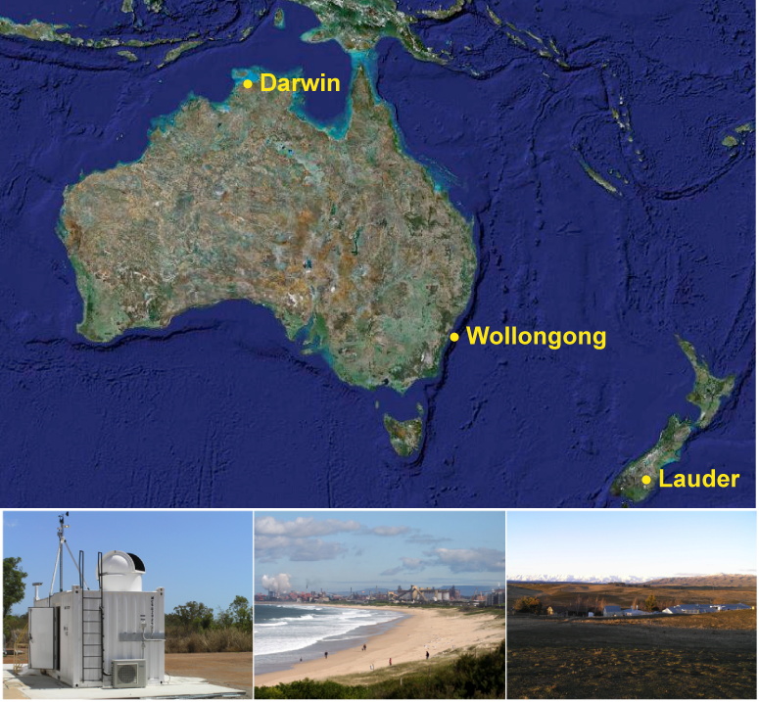

Figure XXX. FTS measurement sites: Darwin (left), Wollongong (center) and Lauder (right).
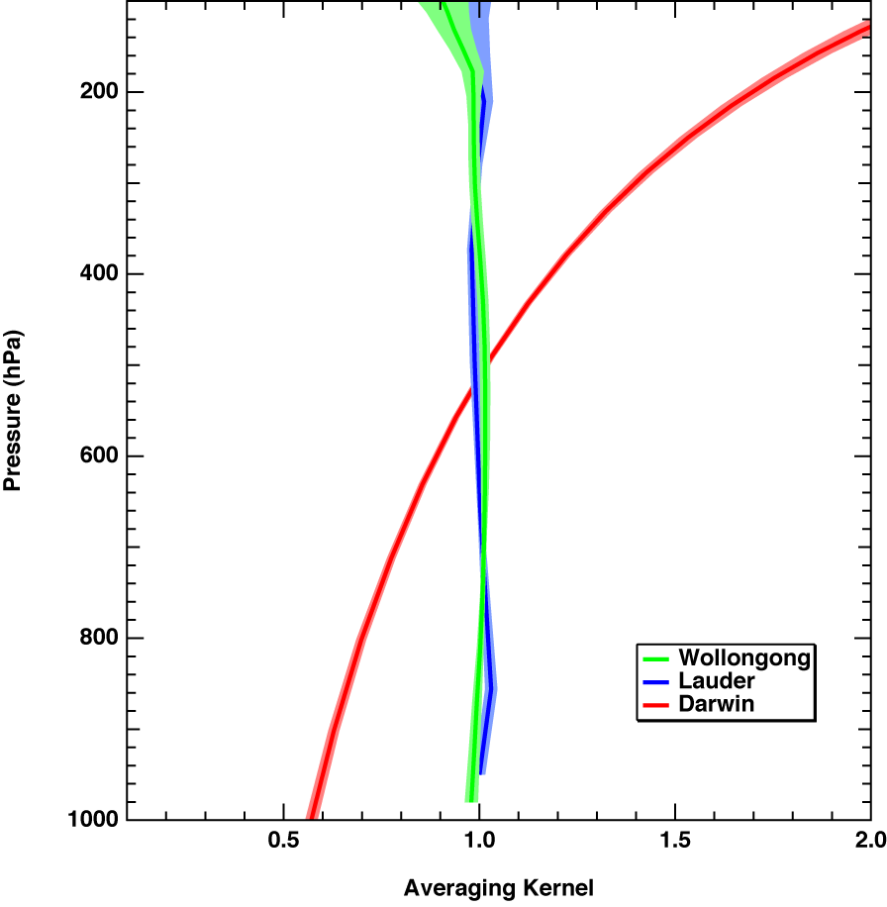

Figure XXX. FTS AKs. For Wollongong and Lauder the indicated spread represents the standard deviation for the AK variation over the year 2008 and covers SZA to about 80°. The spread in the Darwin AK represents the standard deviation over the years 2006–2008 for SZA less than 85°.
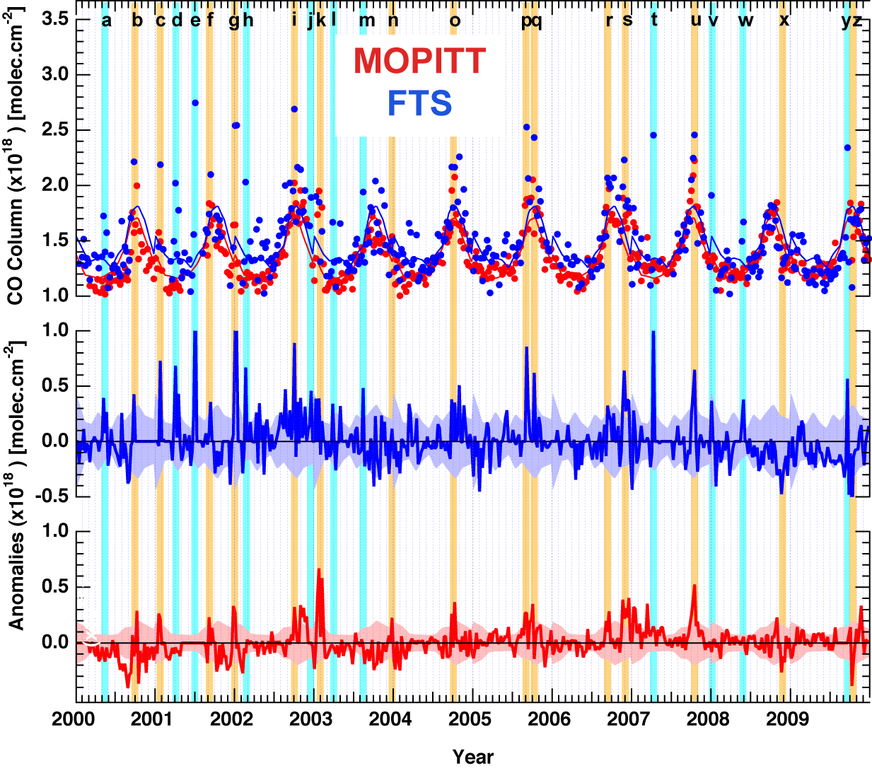
Figure XXX. CO total column observations over Wollongong. The FTS weekly-averaged data are shown in blue and the corresponding MOPITT data in red. The lower plots show the respective weekly anomalies referred to a monthly mean background averaged over all years. The shaded envelope on the anomaly plots represents the standard deviation of the monthly mean background. ‘Events’ are defined as anomalies that rise above this interannual monthly variability. These are indicated for events captured only by the FTS (light blue vertical lines) and for both sensors (orange vertical lines). See Table 1 and main text for description of events.
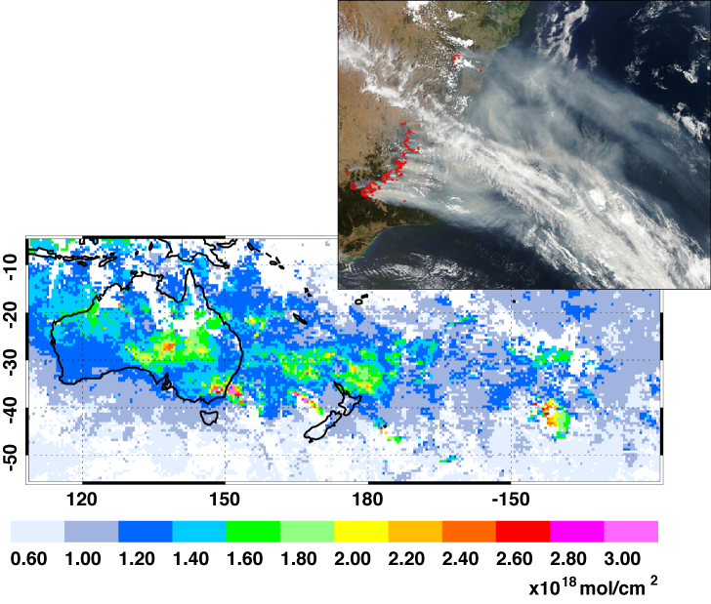

Figure XXX. (Top) Aqua/MODIS true-color image acquired over NSW Jan. 21, 2003. (Bottom) MOPITT CO total column for Jan. 17–23, 2003. MODIS Image by J. Descloitres, MODIS Rapid Response Team, NASA GSFC.
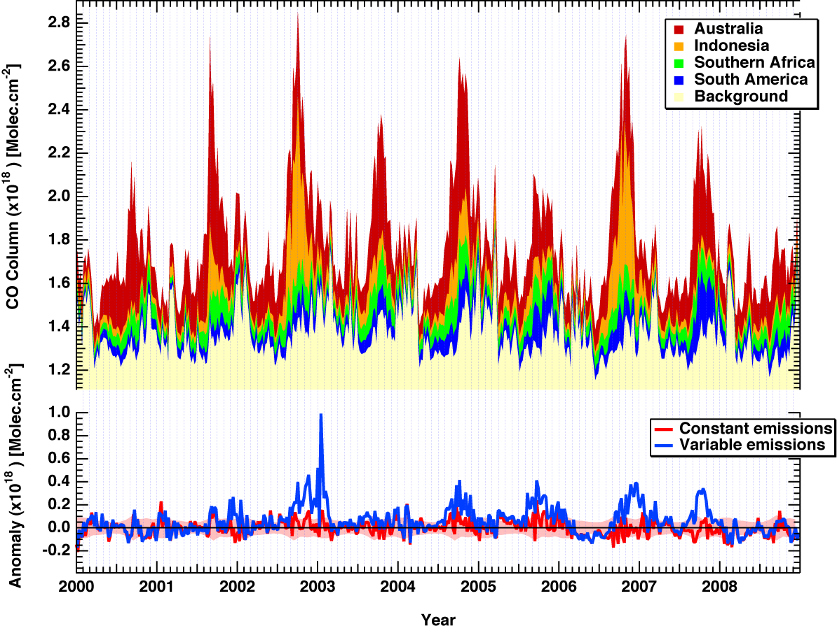Figure XXX. A 2.8 degree MOZART-4 tag run showing the build-up of the contributions of different SH source regions to the CO total column over Wollongong (top plot). The background (shown in yellow) represents the contribution of other sources, principally chemical production and NH sources. Emissions for this run come from the MOZART-4 standard inventory at monthly resolution as described in the text. Anomalies are also shown (bottom plot) for the weekly-averaged CO total column. These are referred to a monthly-mean background averaged over all years calculated from a second model run that also assumes yearly-invariant emissions, actually those for 2000. The shaded envelope on the anomaly plots represents the standard deviation of this monthly-mean background. Since the emissions are the same each year, anomalies (shown in red) arise as a result of interannual variability in meteorology and transport alone. The anomalies for the CO total column from the tag model run using variable emissions (shown in blue) show the combined effect of interannual variability in meteorology, transport and emissions.

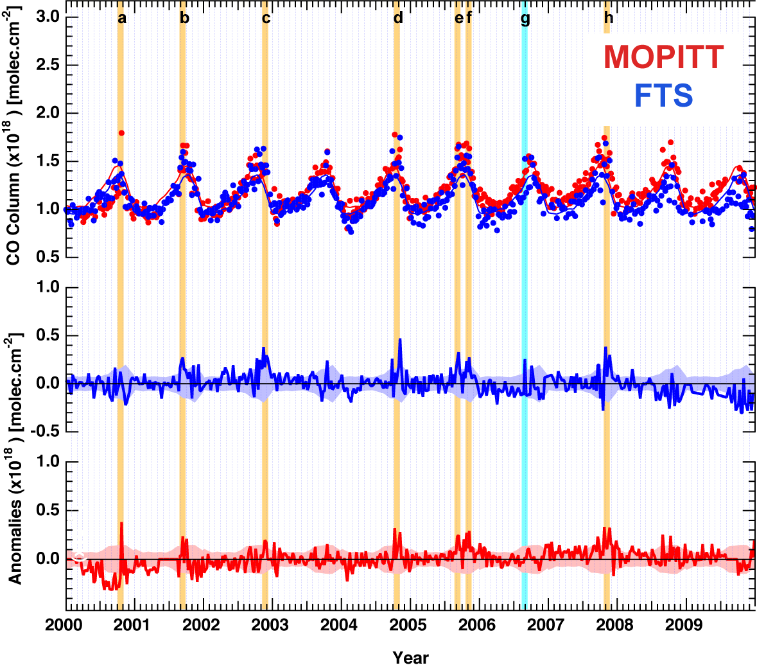
Figure XXX. CO over Lauder New Zealand. FTS (blue) and MOPITT (red).
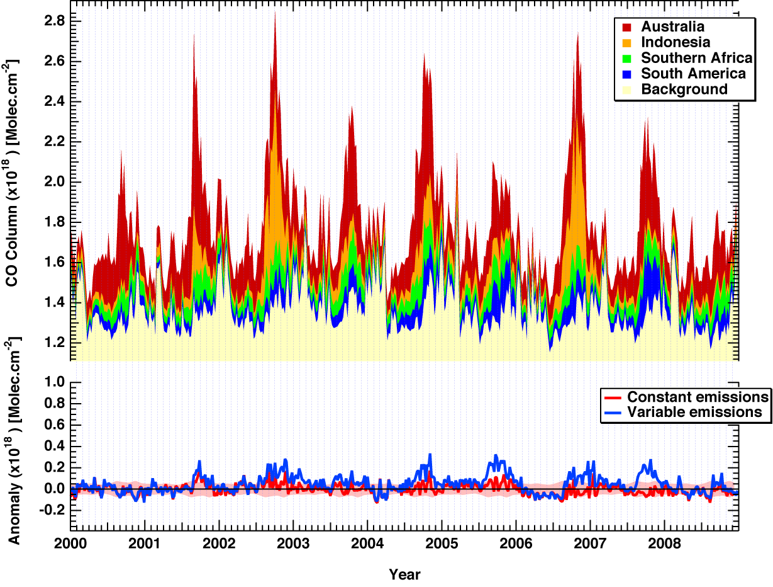
Figure XXX. As for Figure XXX but for MOZART-4 CO tags over Lauder New Zealand.

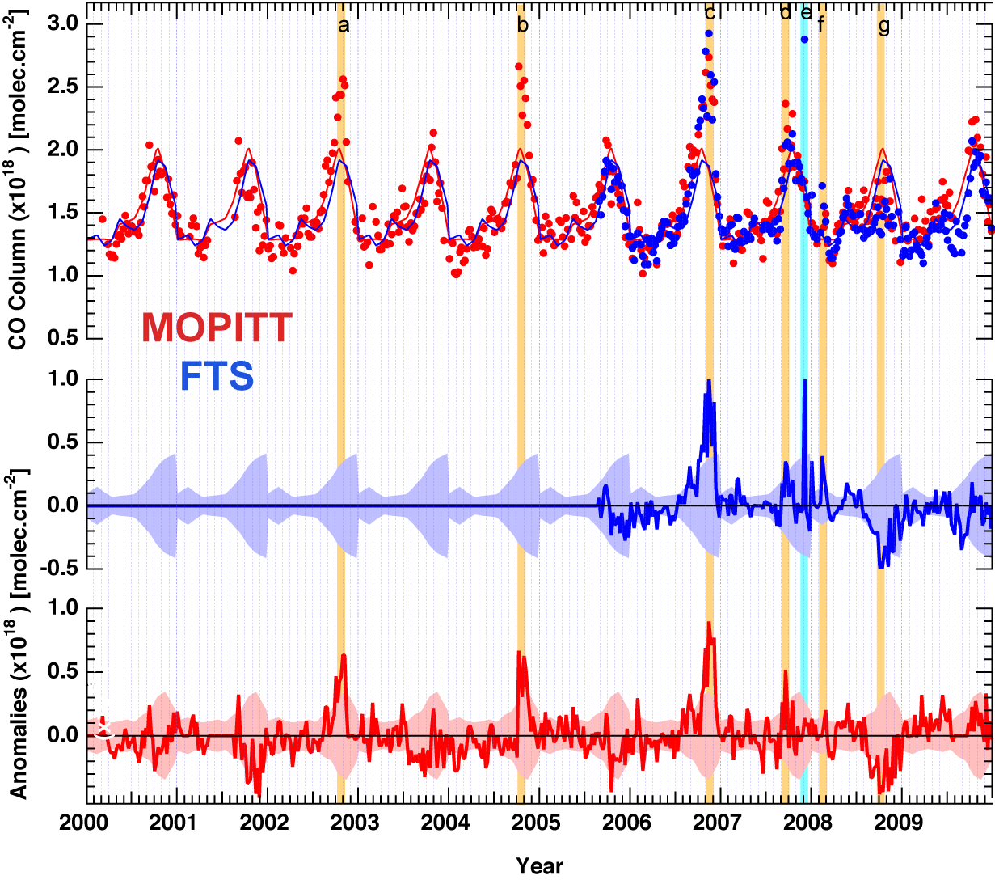
Figure XXX. As for Figure XXX but now showing CO total column observations over Darwin.
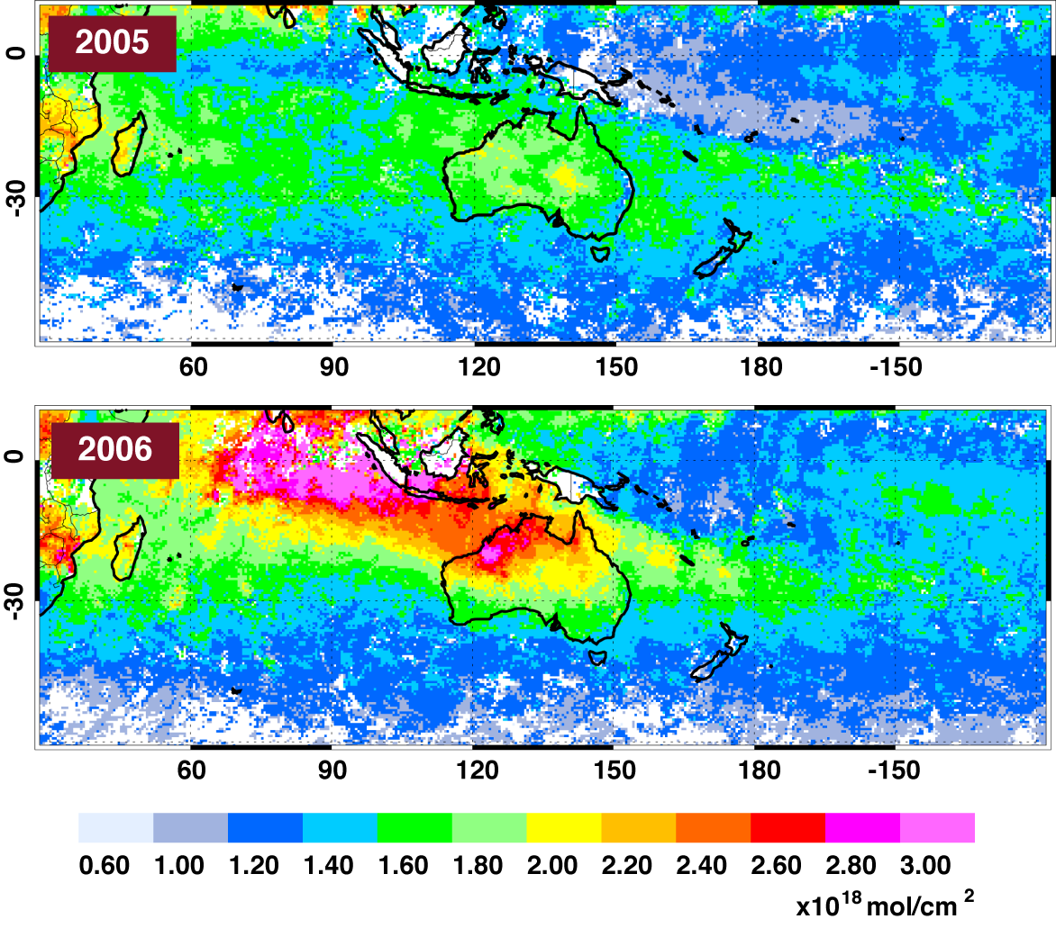
Figure XXX. November mean distributions of MOPITT CO total column
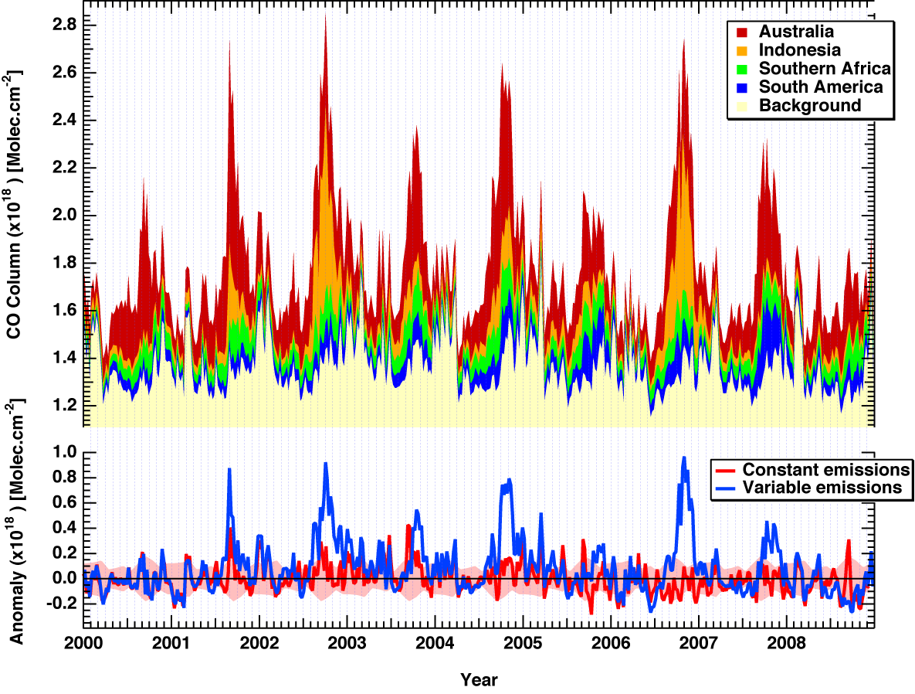
Figure XXX. As for Figure XXX but for MOZART-4 CO tags over Darwin.

